Table of Contents

1.0 Introduction 2

1.1 Project Background 2

1.2 Technologies used 3

2.0 Webpage Design 5

3.0 Code Sample 10

4.0 Reflective 12

4.1 Self Reflective 12

4.2 Strength of Project 13

4.3 Weakness of Project 14

4.4 Future Suggestions 15

4.5 Summary 15

# 1.0 Introduction

## 1.1 Project Background

I have chosen to design a men fashion e-commerce website called The Lighters for my web developing assignment. The Lighters clothing store allows the publics to shop for their desired clothing materials on the internet without visiting physical clothing store like what older generations did. The Lighters provides free delivery service for the customers and free return and exchange of items. The Lighters offers few categories for the customers, like T-shirt, Polo T-shirt, Pants, Belts, Wallet, Underwear and Socks. However, customer will need to register as a member before buying an item on The Lighters and only able to buy an item after logging in his or her account. There is a purchase history page being shown to the customer where the customer able to check what have they bought in the past.

## 1.2 Technologies used

**HTML**

Figure 1.2.1 show example code of HTML. Hypertext Markup Language (HTML) is the standard markup language for creating web pages and web applications. With Cascading Style Sheets (CSS) and JavaScript it forms a triad of cornerstone technologies for the World Wide Web.

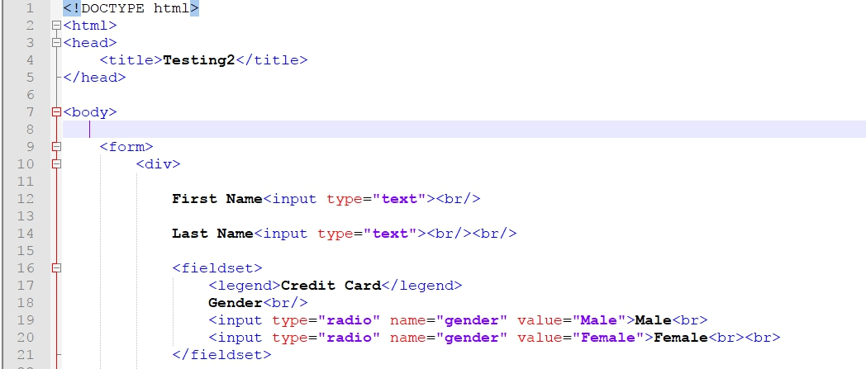

Figure .2.1 HTML Code

**CSS**

Figure 1.2.2 show example code of CSS. Cascading Style Sheets (CSS) is a style sheet language used for describing the presentation of a document written in a markup language.

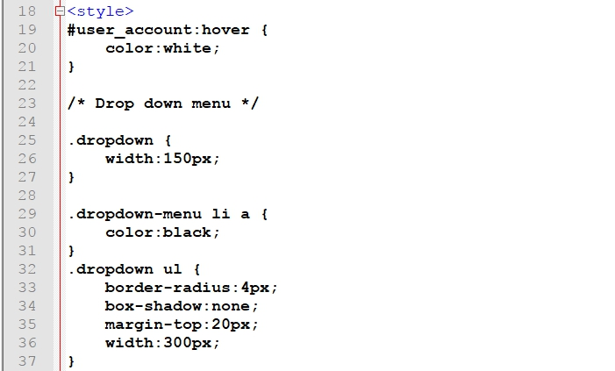

Figure 1.2.2 CSS Code

**JavaScript**

Figure 1.2.3 show example code of JavaScript. JavaScript is an interpreted programming language which is used to make webpages interactive and provide online programs.

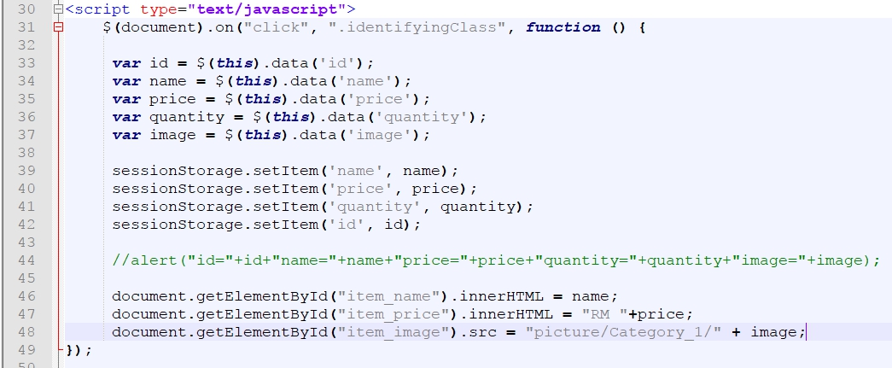

Figure 1.2.3 JavaScript Code

**PHP**

Figure 1.2.4 show example code of PHP. PHP is a server-side scripting language designed primarily for web development but also used as a general-purpose programming language.

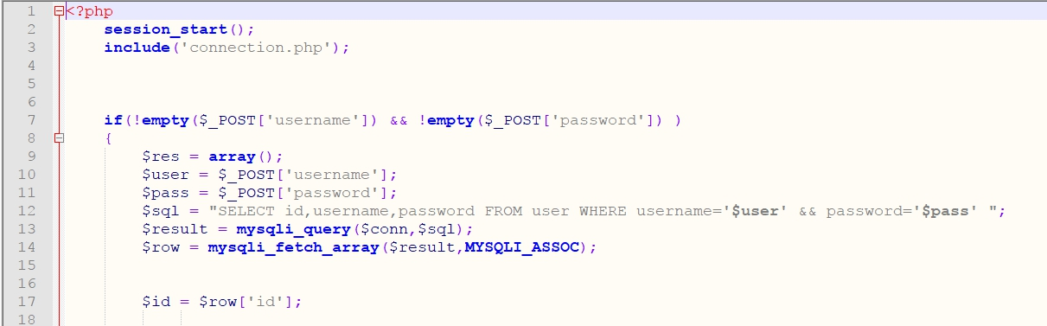

Figure 1.2.4 PHP Code

# 2.0 Webpage Design

**The Lighters – Home Page**

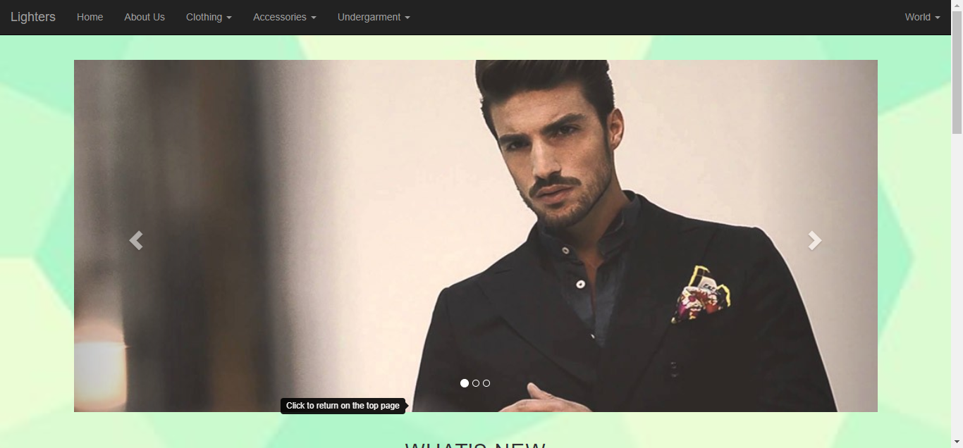

Diagram 2.0.1 Home Page of The Lighters

Diagram 2.0.1 shows the Home page of the website of The Lighters. Customers are shown the latest clothing materials available at our site and **sign up** or **log in** to our website at the top right corner of the web page. There are two sections, new arrival and also sales under the slideshow at the top of the page to let customer know which item is on sales or just arrived.

**The Lighters – About Us Page**

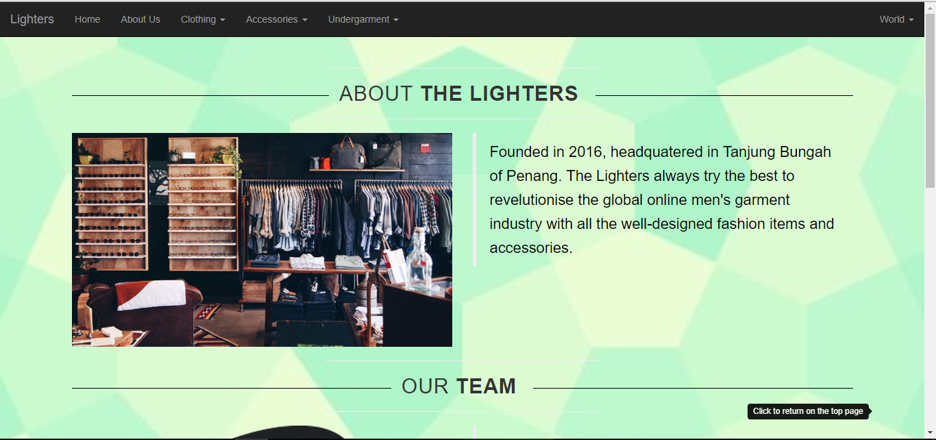

Diagram 2.0.2 About Us page of The Lighters

Diagram 2.0.2 shows the About Us page of The Lighters. Customers get to know more about the company background.



Diagram 2.0.3 Contact Us section of The Lighters

Diagram 2.0.3 shows the methods of the customers contacting the company.

**The Lighters – Product Page**

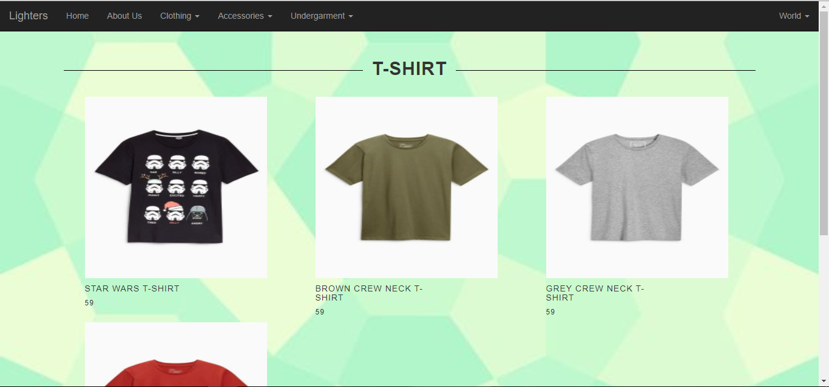

Diagram 2.0.4 Product page of The Lighters

Diagram 2.0.4 shows one of the product page of The Lighters.

**The Lighters – Product Detail Page**

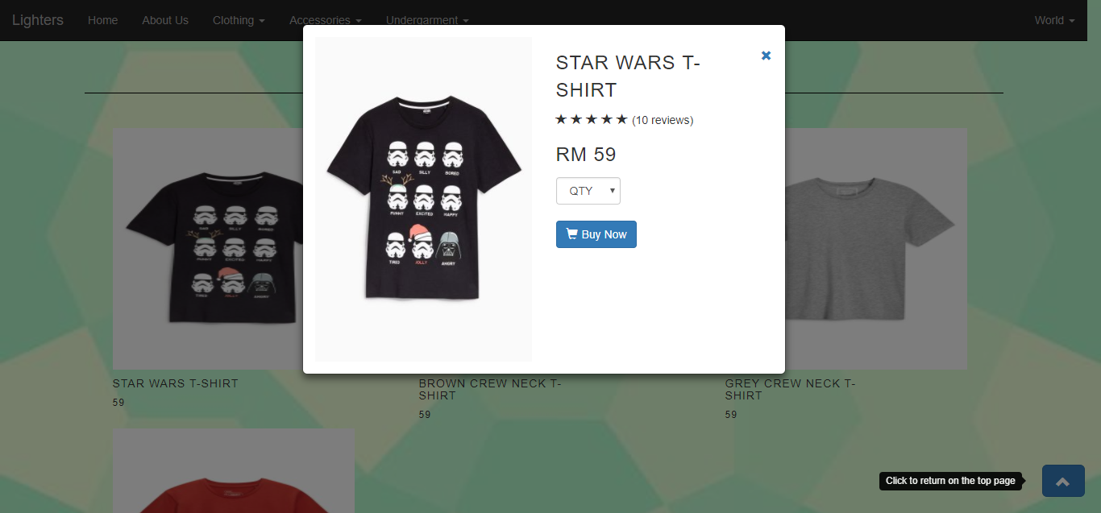

Diagram 2.0.5 Product detail page of The Lighters

Diagram 2.0.5 shows one of the product detail page of an item from The Lighters. Customer can choose the quantity that he or she wants to buy.

**The Lighters – Order Page**

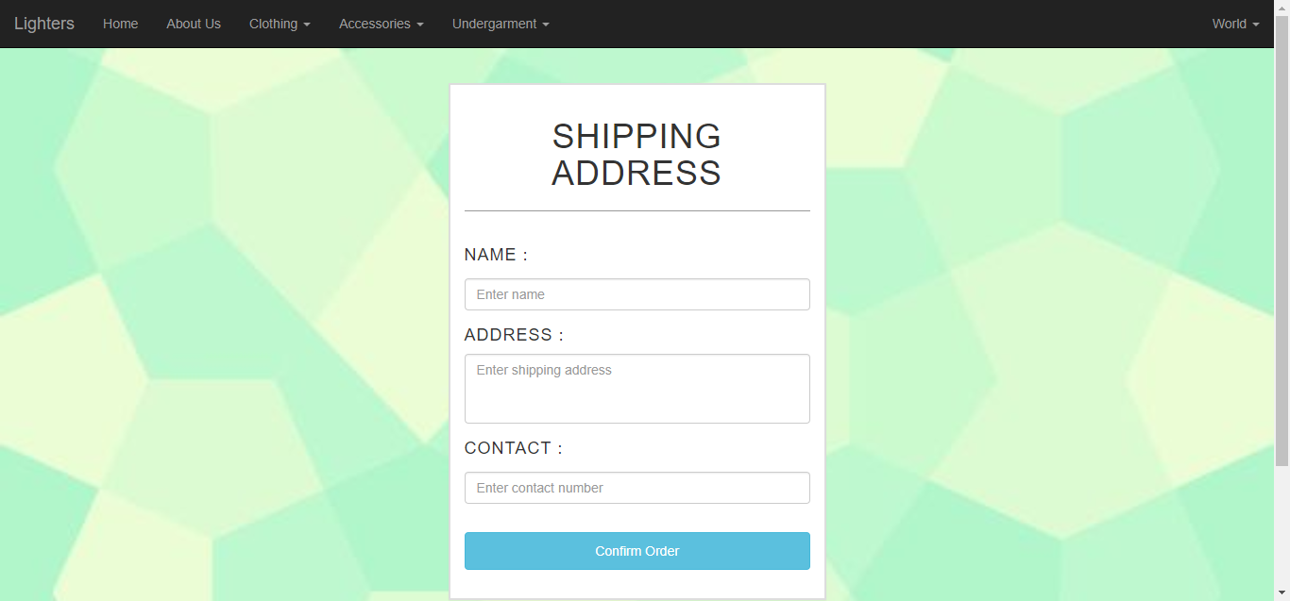

Diagram 2.0.6 Shipping Address form to be filled in by the customer

Diagram 2.0.6 shows the shipping address form to be filled in by the customer in order to place the order.

**The Lighters – Sign Up Page**

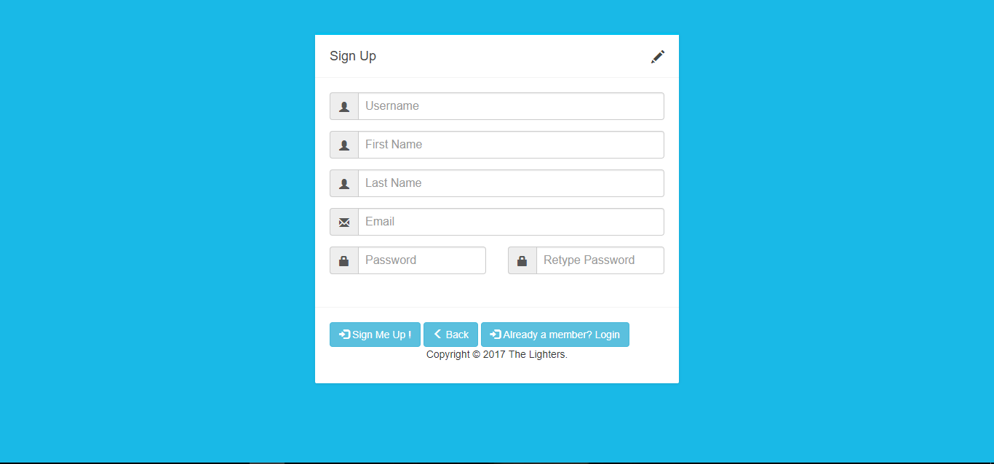

Diagram 2.0.7 Sign Up Form of The Lighters

Diagram 2.0.7 shows the Sign Up form of The Lighters when the customer wants to register themselves as a member to purchase something. There are real-time validation running at the background when user type in the required input.

**The Lighters – Log In Page**

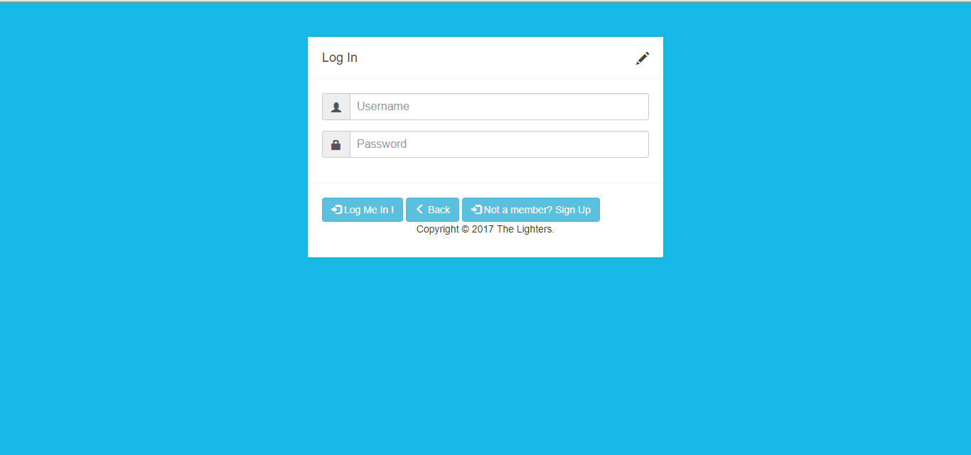

Diagram 2.0.8 Log In Form of The Lighters

Diagram 2.0.8 shows the Log In form of The Lighters. Members can log in through this page.

**The Lighters – Order History Page**

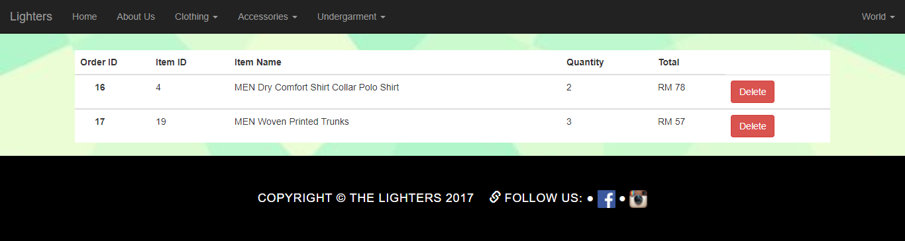

Diagram 2.0.9 Order History Page of The Lighters

Diagram 2.0.9 shows the Order History page of The Lighters. Members can view their purchased items at this page.

# 3.0 Code Sample

The data toggle and data target of the button in diagram 3.0.1 opens the popup modal which based on the id of the modal. For example, when user click on the button, the modal in diagram 3.0.2 that has the id which is product_view will be open.

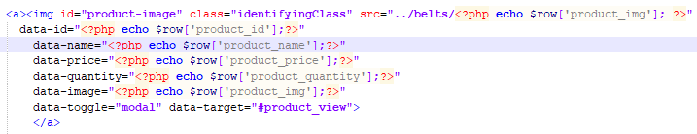

Diagram .0.1

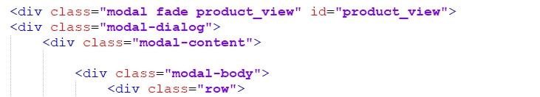

Diagram 3.0.2

In diagram 3.0.3, document.getElementById function is used in order to display the related information such as the price, quantity and image on the popup modal when user click to view the detail of the item.

sessionStorage.setItem function is used to temporally store the id of the product when user click to view the product detail. Thus, sessionStorage.getItem function will be used to get the id of the product at the end of the purchasing step which is the confirm product page.

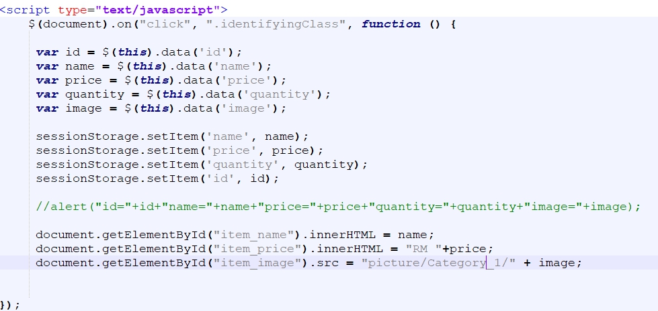

Diagram 3.0.3

In Diagram 3.0.4, there are validations. There are the validations for the Sign Up form. User will be prompted with live error message when user enter invalid inputs.

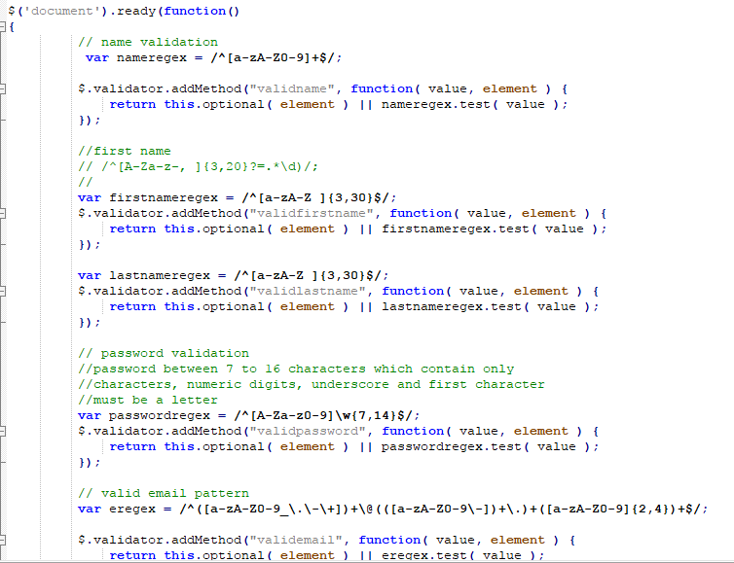

Diagram 3.0.

# 4.0 Reflective

## 4.1 Self Reflective

I have become more self-independent than before after finishing the assignment. I do not have any idea or skill to develop the website thus I went and searched through the web to get some idea about it. My time management skill has improved after doing this project because I spent the spare times doing the project and managed to complete the project before the submission date as given by the tutor. The assignment itself is not a big deal, just that it need times to make it perfect or user-friendly to the most and the best.

I’m glad that my tutor, Ms Chern for teaching me a new programming language like PHP and a framework like Bootstrap to develop my website. My website is more beautified after implementing the framework Bootstrap as it provides many ready-to-go design and classes. It also gains myself more knowledge on website developing.

## 4.2 Strength of Project

The Sign Up form will be the strength of the project. The form is supported with real-time validation which reside in the register.js file. As the user key in the input into a particular input field, the input area will be validated with the validation pattern like input field for user name should contain only alphabets and digits. Besides Sign Up form, login function is another strength of the project. User will only able to make a purchase after they log in to his or her account.

Database is also implemented in this project. The images shown in the website are all retrieved from the folder, matched with the image file name and displayed. Besides displaying products, purchasing products, signing up, and logging in are all using database to get them working seamlessly. Session in PHP is also used to make sure the customer is logged in before purchasing any product.

The website separates the products into a few departments and users can click into different departments as the tabs shown in the navbar.

The website also provides pop-up modal to make user clearer about the item when an item is clicked. User can select the quantity of the product and they click the button beneath the quantity selection box to proceed.

## 4.3 Weakness of Project

One of the weaknesses can be found out in the website is that the dropdown lists would not show full drop-down menu when the user mouse over them. This is not user-friendly as people nowadays want everything to be user-friendly like you mouse over certain things and they will show the result. In this website, user will have to click the main tab first to show the full menu of certain category.

Besides drop-down menu, user is not able to know which section he or she is in. The navigation bar only shows few tabs for the user to click, so there’s no single indicator showing user which section is he or she in. User can only see the section name in the browser’s tab which is not professional.

Contact Us section is another weakness found in this website. The website doesn’t provide a contact form to let the user fill in, instead the website only displays the methods of reaching the company under ‘About Us’ section. The website should provide a contact form for the user other than display the methods only because this makes user feel unpleasant as they need to open his or her mailbox to compose the feedback to the company.

The website doesn’t have a shopping cart function which is not right at all. The user can’t choose multiple items that they want to buy and only fill in the shipping form once. The website needs user to fill in the shipping form once for each item.

Furthermore, the website doesn’t provide payment method for the user to make payment for his or her order.

## 4.4 Future Suggestions

Shopping cart is one of the feature to be added to the website because it is a necessary function for an e-commerce site to work in perfect conditions. User will feel more pleasant as he or she able to select multiple items before they want to make payment for them. Besides shopping cart, payment method should also be made available to the user. It is best advised not to let the user pay for the items through Cash on Delivery(COD) method.

## 4.5 Summary

In conclusion, the website is considered quite a successful project as it able to make the functions work correctly and precisely despite there are some flaws need to be fixed or improved.